Abstract
Faction win rate is one of the most reported measures of competitive balance in Warhammer: Age of Sigmar. However, an observed faction win rate reflects not only the relative strength of the faction being played, but also the strength of the players selecting it, their army construction choices, the opponents they face at events and other sources that will affect the variation. As with many tabletop wargames, player strength is unevenly distributed between Factions, and raw win rates may therefore provide a misleading estimate of underlying Faction strength.
This paper presents WoElo, a match-level Elo-based framework developed by me to model player strength and investigate the extent to which player ability and army selection contribute to the outcomes of tournaments. Player ratings are updated sequentially from individual game results, while Faction and Battle Formation (or Army of Renown) effects are estimated from performance relative to that expected from the participating players. Regularisation is applied to these effects to reduce the influence of small samples. The framework therefore distinguishes between observed performance of an army and the performance that would be expected from the players using it.
The methodology is evaluated using a time-based out-of-sample validation design. The information available through the end of July 2026 provides the starting point for the August 2026 holdout. Player ratings then continue to update sequentially as August games occur, while contextual parameters used for holdout evaluation are not retrospectively re-estimated using later August results. Predictive accuracy is assessed primarily using the Brier score, supplemented by calibration analysis, paired physical-match bootstrap resampling, alternative model specifications and sensitivity testing. Four principal specifications are compared: Player Only, Player plus Faction, Player plus Battle Formation (or Army of Renown), and Player plus Faction with residual Battle Formation effects.
Player strength provides much of the predictive information captured by the models. Adding Faction-level effects to player ratings does not improve out-of-sample prediction in the principal validation sample, whereas incorporating Battle Formation (or Army of Renown) produces the lowest Brier score of the tested specifications. The improvement of the Player plus Formation model over Player Only is modest and its bootstrap confidence interval narrowly includes zero; consequently, the evidence for incremental Formation-level predictive value is considered suggestive rather than conclusive. Formation (or Army of Renown) information becomes more informative as the difference in player rating decreases, indicating that army choice may become increasingly relevant where competitors are more closely matched in estimated ability.
A separate skill-matching sensitivity analysis demonstrates an important distinction between predictive and balance measurement. Restricting the dataset to games between more similarly rated players changes raw faction win rates more than would ordinarily be expected from equivalent random reductions in sample size, while skill-adjusted Faction estimates remain substantially more stable. This provides empirical evidence that the composition of a Faction’s player population can materially influence its observed win rate and that controlling for player strength can improve the stability of faction-level performance estimates.
The results do not imply that tournament outcomes can be attributed to fixed percentages of player skill and army strength. WoElo does not presently model several potentially important determinants of game outcomes, including detailed army composition, faction matchups, battleplans and other contextual effects. Instead, the findings demonstrate that player strength is an important confounding variable in tournament balance analysis and that raw faction win rate should not, in isolation, be interpreted as a direct measure of Faction strength.
WoElo is therefore proposed not as a replacement for conventional win-rate reporting, but as a complementary framework through which observed tournament results can be separated from differences in the populations of players generating them. By combining raw results, player-strength estimates, army-level effects and explicit out-of-sample validation, the methodology aims to provide a more rigorous basis for interpreting competitive Warhammer: Age of Sigmar data.

Executive Summary
WoElo is a match-level analytical framework designed to separate persistent player performance from the army context present in competitive Age of Sigmar results. It complements rather than replaces raw win rate: raw win rate describes what happened, while WoElo asks whether those results were unusual given the players involved.
The framework was evaluated prospectively using August 2026 tournament games as a temporal holdout, with player ratings and contextual information established from data available before the holdout. On a common sample of 2,691 physical matches, Player + Battle Formation produced the lowest Brier score of the principal specifications (0.200797 versus 0.201775 for Player Only), although the paired bootstrap interval for that incremental improvement crossed zero. Formation-level predictive value is therefore suggestive rather than conclusive.
The strongest balance-analysis result concerns player composition. Restricting games to more closely matched players moved raw Faction win rates by an average of 3.81 percentage points, compared with 2.96 points under equivalent random sample reduction. WoElo-adjusted Faction estimates moved only 1.22 points, compared with 1.35 points in random subsets. This provides evidence that who plays a Faction materially affects the raw win rate observed, while adjustment for player strength produces more stable Faction-level estimates.
WoElo should not be interpreted as a causal decomposition of player skill and army strength. It is an observational predictive framework. Its intended use is to place raw results alongside player expectation, uncertainty and army context so that competitive performance can be interpreted with greater precision.

Introduction: The Problem with Raw Win Rates
Faction win rate has long been one of the first numbers we reach for when talking about balance in competitive Warhammer: Age of Sigmar. There is a good reason for that: it is simple, easy to communicate and immediately understandable. If one Faction wins 55% of its tournament games and another wins 45%, the obvious conclusion is that the first is stronger.
That does not make win rate a bad statistic. It tells us exactly what happened in the games we measured. A Faction that wins 55 games out of 100 has performed better in that sample than one that wins 45.
The problem begins when we ask that descriptive statistic to tell us something it was never designed to measure directly: the underlying strength of the Faction itself.
A tournament game is not played by two factions in isolation. It is played by two players, using armies, within competitive circumstances. The observed result therefore reflects several interacting influences. At a minimum these include the relative ability of the two players, the Factions selected, the Battle Formations (or Army of Renown) used and random variation. Other factors not presently incorporated into the WoElo model may include detailed army composition, Faction matchups, battleplan and other contextual effects.
Consequently, an observed faction win rate can be expressed conceptually as:
Observed Faction Performance=f (Player Strength, Faction Strength, Army Construction, Context, Noise)
A raw win rate does not attempt to separate these components.
That gap between what happened and why it happened is the problem WoElo is intended to explore.

Win rate describes outcomes, not causes
Consider two hypothetical Factions, each recording a 55% tournament win rate. At first glance, their competitive performance appears identical. However, suppose the players using Faction A would, based upon their previous results and the strength of their opponents, have been expected to win approximately 54% of their games. Players using Faction B, by contrast, would have been expected to win only 48%.
The headline number is identical, but the story underneath it is not.
Faction A has performed approximately in line with the results expected from its player population:
55%−54% = +1 percentage point
Faction B has substantially exceeded its player strength expectation:
55%−48% = +7 percentage points
Conversely, a Faction recording a below average raw win rate need not necessarily be intrinsically weak. If its player population was expected to perform even worse, the faction may have enabled those players to outperform their underlying expectation. The raw win rate remains correct in every case. What changes is its interpretation.
For balance analysis, then, I do not think the useful question is only: How often did this Faction win? We should also ask: How often should we have expected these players to win?
The difference between those quantities provides a route towards separating player-population effects from army-level effects.

Player populations are not randomly distributed
Raw Faction win rate would be much easier to interpret as a measure of Faction strength if players were randomly assigned armies. They are not. Players choose what they take to an event, so there is no reason to expect player ability to be spread evenly across Factions.
Competitive Warhammer: Age of Sigmar does not operate this way, as the players choose their armies ahead of an event, without knowing which opponents they will face.
Those choices may be influenced by the current competitive strength, familiarity, model ownership, aesthetics, cost, complexity, recent rules changes, tournament preparation and numerous other factors. Experienced competitors may gravitate towards Factions or builds, while other Factions may attract a broader or less experienced population.
There is therefore no reason to assume that the average strength of the players using each Faction is equal, which creates a potential confounding problem.
If stronger players disproportionately select a particular Faction, part of that Faction’s observed win rate may reflect the strength of the population using it. Conversely, a Faction disproportionately represented by weaker players may record a lower win rate even if the rules themselves are competitively adequate.
A simplified relationship is:
Unless player-strength differences and other relevant influences are either negligible or adequately controlled.
This does not make conventional win-rate analysis invalid. It means that its scope must be understood correctly.

The ecological problem of Faction-level statistics
There is also a more general statistical problem with aggregating thousands of individual games into a single faction-level percentage.
A faction win rate is a population statistic. It describes the collective performance of all recorded players using that faction. It does not distinguish between the distribution of results within that population.
For example, a 55% faction win rate could arise from:
- a broad population of players each performing moderately above average;
- a small number of highly successful players accompanied by many weaker players;
- unusually strong players producing results approximately consistent with their individual expectations;
- ordinary players systematically exceeding those expectations;
- a particularly effective subset of Battle Formations or army constructions;
- or some combination of these effects.
These situations can produce the same headline statistic while having very different implications for competitive balance. Representation therefore matters alongside win rate, as does the distribution of player strength within that representation.
This becomes particularly important when comparing factions with substantially different tournament populations. Two factions may each have played 500 games, but those 500 games need not represent equivalent competitive populations.

Army strength also exists below Faction level
There is another complication: Faction is a fairly blunt level at which to analyse an army.
Within a single faction, players may select different Battle Formations. Those Formations can alter army construction, rules interactions and the incentives surrounding unit selection. If some Formations systematically outperform others, a faction-wide average can obscure meaningful internal variation.
A faction recording an apparently balanced 50%-win rate might, for example, contain one Formation substantially above expectation and another substantially below it.
Likewise, a faction with a high overall win rate might owe much of that performance to a single dominant Formation rather than uniformly strong rules.
This creates a hierarchy:
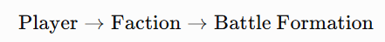
The methodology developed here therefore investigates not merely whether faction identity improves prediction once player strength is known, but whether the more granular Battle Formation level contains additional predictive information.
Importantly, Battle Formation should not automatically be interpreted as the causal source of any measured effect. Formation choice may correlate with other characteristics of an army, including units and enhancements. In the present framework, Formation is therefore treated as an observable army-level predictor rather than proof of a specific rule’s mechanism.

Prediction and balance are related but different questions
One distinction became increasingly important as I developed and tested WoElo.
The variables that best predict tournament game outcomes are not necessarily identical to those most useful for evaluating game balance.
Consider a game between a very strong player and a substantially weaker player. Player strength may overwhelmingly determine the expected result. Knowing the factions or Battle Formations involved may add comparatively little predictive information. That game remains legitimate tournament data. However, it may contain relatively limited information about the competitive difference between the two armies because the player-strength differential dominates the expected outcome.
Now consider two players of approximately equal ability. Player strength provides much less information about which competitor should win. Differences associated with faction or army selection can therefore become proportionately more informative.
This suggests two distinct analytical questions:
Prediction: Given everything currently known, who is more likely to win?
and:
Balance: After accounting for differences between the players, what evidence remains of army-level advantage?
WoElo is designed primarily to provide the player-strength component required to investigate both questions.

Why Elo?
A useful player-strength measure for this purpose needs several characteristics.
It must operate at individual game level, respond to the strength of the opposition, update as new evidence becomes available and generate an expected probability of victory between two competitors.
An Elo-type rating system provides these properties.
Rather than treating every win equally, Elo evaluates a result relative to expectation. Defeating a substantially stronger opponent provides more evidence of player strength than defeating a substantially weaker opponent. Likewise, losing to a much stronger opponent provides less negative information than an unexpected defeat.
For players \(A\) and \(B\), the conventional Elo expectation takes the form:
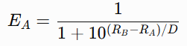
where \(R_A\) and \(R_B\) represent the respective player ratings and \(D\) controls the relationship between rating difference and expected probability.
This produces something raw win rate alone cannot provide: a game-specific expectation before observing the result.
That expectation forms the foundation of the WoElo framework.

From ranking system to analytical control
WoElo was initially motivated by the desire to measure tournament player performance more meaningfully. However, its more important analytical application is not the production of a player leaderboard.
A player-rating system provides an estimate of the expected outcome attributable to the relative strength of the competitors. Once that expectation exists, observed faction and Formation results can be evaluated relative to it.
Suppose players using a particular army collectively record a 57%-win rate. If their WoElo ratings imply that they should have won approximately 56% of those games, relatively little unexplained army-level performance remains.
If another army also records 57%, but its players were expected to win only 49%, the residual signal is considerably larger.
This motivates the central principle of the methodology:
Army performance should be evaluated relative to player expectation, not solely relative to 50%.
The purpose is not to eliminate raw win rate. Raw win rate remains an essential descriptive statistic and provides information immediately understandable to players.
Instead, WoElo adds a second analytical layer: Raw win rate asks what happened.
WoElo-adjusted analysis asks whether what happened was unusual given the players involved.

Research objectives
This technical study therefore examines whether incorporating estimated player strength improves the interpretation and prediction of competitive Age of Sigmar tournament results.
Specifically, it investigates the following questions:
- Can match-level WoElo ratings generate useful out-of-sample predictions of tournament game outcomes?
- Does faction information improve those predictions once player strength has been incorporated?
- Does Battle Formation provide additional predictive information beyond player strength?
- Does a hierarchical model separating faction effects from residual Formation effects improve predictive performance?
- How does the relative predictive importance of player and army information change as the difference in player strength decreases?
- Are raw faction win rates sensitive to the strength distribution of the players generating them?
- Are skill-adjusted faction estimates more stable than raw win rates when large player-strength mismatches are removed?
- Are the principal findings robust to reasonable alternative modelling assumptions and parameter choices?
These questions are evaluated through temporal out-of-sample testing rather than by measuring how closely the model reproduces the same games from which its parameters were estimated. Where possible, uncertainty is assessed at the level of the physical match to avoid artificially treating reciprocal player-perspective records as independent observations.
The objective is not to construct a model capable of explaining every tournament result. Such a model would require substantially more information than is presently incorporated. Rather, the purpose is to determine whether explicitly accounting for player strength provides useful information beyond conventional faction win rates and whether army-level effects can subsequently be detected without conflating them with differences in the players selecting those armies.

Data and Study Design

Tournament dataset
WoElo was developed using match-level results from competitive Warhammer: Age of Sigmar tournaments. The dataset consists of games played at Grand Tournament (GT) level events, defined for the purpose of this study as multi-round, two-day competitive events.
Tournament results were collected from several commonly used event-hosting platforms, including Best Coast Pairings (BCP), Milarki, Ecksen, MiniHQ, Longshanks, Tabletop Herald and ChampionsHub. Where available, the data collected for each game included the event, round, player, opponent, result, Faction, Battle Formation (or Army of Renown) and battleplan.
The fundamental observation used by WoElo is therefore the individual game, rather than a player’s final tournament record or finishing position. A five-round tournament normally contributes five observations to a player’s rating history rather than a single aggregate result.
This distinction applies because tournament records conceal information relevant to estimating player strength. Two players finishing with four wins and one loss may have faced substantially different levels of opposition. Match-level modelling allows the strength of each opponent, and the context in which each game was played, to be considered separately.
Only completed games for which the information required by the relevant analysis was available were included. Consequently, sample sizes may differ between analyses where additional information such as Battle Formation, was required.

Match representation
Tournament games are stored from the perspective of each participating player. A physical game between Player A and Player B therefore normally produces two reciprocal records; one describing Player A’s result against Player B and another describing Player B's result against Player A.
Results are represented numerically as:
1 Win
S= 0.5 Draw
0 Loss
This reciprocal structure is convenient for calculating player histories, faction statistics and contextual predictions because every player’s games can be evaluated from that player’s perspective.
However, the two records do not constitute two independent games. Where statistical inference requires independent observations, most notably bootstrap comparisons between predictive models, the reciprocal records are collapsed to the underlying physical match so that a single game is not treated as two independent observations.
Descriptive statistics may use the player-perspective structure where appropriate, provided that the interpretation of the resulting sample is clear.

Player identification and historical ratings
Players are tracked longitudinally across events so their rating entering a game reflects their competitive history rather than their performance at that event alone.
Where a player has an existing WoElo rating from the historical dataset, that rating provides the starting point for subsequent chronological updates. Players without an identifiable previous competitive record enter the system at a rating of 300.
WoElo is updated after individual games. Consequently, a player’s rating during a tournament may change from round to round. The rating used to predict a game is always the player’s rating before that game is played.
This chronological treatment is essential to the design of the system. A player’s later results must not be allowed to influence the rating used to predict an earlier game.
The same principle applies when calculating opponent strength. Expected results are based on the ratings available to both players immediately before the relevant match.

Temporal ordering and information leakage
All WoElo calculations are performed chronologically. For a game played at time t, the model may use information available before t, but not information generated by that game or by games occurring later.
This prevents information leakage, in which future outcomes inadvertently contribute to a supposed out-of-sample prediction.
This distinction is important for tournament data. Using a player’s closing tournament rating, final record or subsequent results to estimate the probability of an earlier-round result would give the model information that would not have been available when that game occurred.
WoElo therefore distinguishes between the rating used to make the prediction and the rating produced after observing the result. The former is used when evaluating predictive performance; the latter becomes available only for subsequent games.

Development and holdout design
Model development and validation were separated temporally. Historical data available through the end of July 2026 were used to establish the player ratings and contextual adjustments entering the validation period. These values were then frozen before evaluating predictions on games played during August 2026.
August therefore acts as a forward chronological holdout rather than a randomly selected subset of the same dataset used to construct the model.
This design was chosen because it more closely resembles the intended real-world use of WoElo. At any given point, the system must use what is known about players, Factions and Battle Formations (or Armies of Renown) to evaluate games that have not yet occurred.
Where faction or formation effects were tested during the holdout, their starting estimates were derived from information available before the holdout period. August outcomes were then used to evaluate how well those previously estimated effects predicted new games.
Analyses conceived after examination of the August holdout are treated as exploratory rather than confirmatory. In particular, parameter values or alternative models selected because they performed well on August data cannot subsequently use the same August games as an independent validation set. Such approaches require evaluation on a later, as yet unseen period before they can be considered validated improvements to WoElo.

Mirror matches
Faction and Battle Formation (or Army of Renown) mirror matches require special treatment depending on the statistic being estimated.
A Faction mirror provides no information about whether that faction is stronger or weaker than another faction regardless of the outcome, the Faction necessarily records both a win and a loss from the reciprocal player perspectives. Faction mirrors are therefore excluded where the objective is to estimate faction-level performance relative to the wider field.
The same principle applies to Battle Formation (or Army of Renown) mirrors when estimating Formation effects. A game in which both players use the same Faction and Formation cannot identify an advantage attributable to that formation over its opponent.
Mirror games can nevertheless remain informative for estimating player strength, because the result still provides information about the relative performance of the two players. Mirror games also provide information on the wider win rate of a Faction or Battle Formation against the wider population, where Faction A is more popular than Faction B, a mirror match will capture the frequency of these games and therefore reflect that frequency within a wider win rate.
Their exclusion from contextual Faction or Battle Formation estimation does not therefore imply their exclusion from either the underlying player-rating system or the wider calculation on broader win rates.

Missing and incomplete observations
Not every tournament source provides the same level of information, and historical records may be incomplete.
The minimum information required for a game to contribute to the player-rating model is the identity of both players and the game result. Analyses requiring additional contextual variables use only games for which those variables are present.
For example, a game may contribute to the estimation of player WoElo while being excluded from a Formation analysis if one or both players’ Battle Formations (or Army of Renown) are unavailable.
This produces different effective sample sizes for different components of the analysis. Sample sizes are therefore reported for the statistic being examined rather than assuming that every model component has access to the complete tournament dataset. No missing Formation or Faction information is inferred from player identity or other results.

Evaluating at the physical-match level
The principal predictive comparisons in this study are evaluated using Brier score, described in Section 4. Because each physical game may be represented by two reciprocal player-perspective records, particular care is required when estimating uncertainty around differences between models.
For descriptive prediction scoring, reciprocal observations produce mathematically complementary predictions and outcomes. However, they remain observations of the same underlying event and cannot reasonably be regarded as statistically independent.
Inferential analyses therefore use the physical match as the resampling unit. Paired bootstrap comparisons resample complete matches and calculate the difference in predictive performance between models within each resampled dataset.
This preserves the dependence between the two player perspectives and, more importantly, ensures that competing models are evaluated on exactly the same games.

Study design philosophy
The purpose of the validation framework is not to identify the most complicated model that can be made to fit historical Age of Sigmar results. It is to determine whether additional information produces a reproducible improvement when predicting games that were not used to estimate that information. The study therefore follows three broad principles.
First, that chronology is preserved. Predictions use only information that would have been available before the game being predicted.
Second, models are compared on like-for-like samples. A model is not considered superior merely because it is evaluated on a different or easier subset of games.
Third, exploratory findings are separated from validated model changes. The August holdout can identify promising hypotheses, but once August results have influenced the design or parametrisation of a new model, those same results can no longer provide an independent test of that model.
These principles informed both the construction of WoElo and the subsequent robustness tests reported in this paper.

The WoElo Model
WoElo is designed to separate persistent player performance from the contextual characteristics of the army being used. A player's WoElo rating is updated sequentially from match results and is intended to represent their demonstrated performance relative to other players within the tournament population. Faction and Battle Formation effects are estimated separately by comparing observed results with those expected from the players involved.
This distinction is deliberate. Army choice may affect the probability of winning an individual game, but allowing estimated army strength to feed directly back into the player rating risks conflating player performance with the strength of the army being used. WoElo therefore maintains a persistent player rating while treating Faction and Battle Formation as contextual adjustments used for analysis and match prediction.
The following sections describe each component of the model in turn.
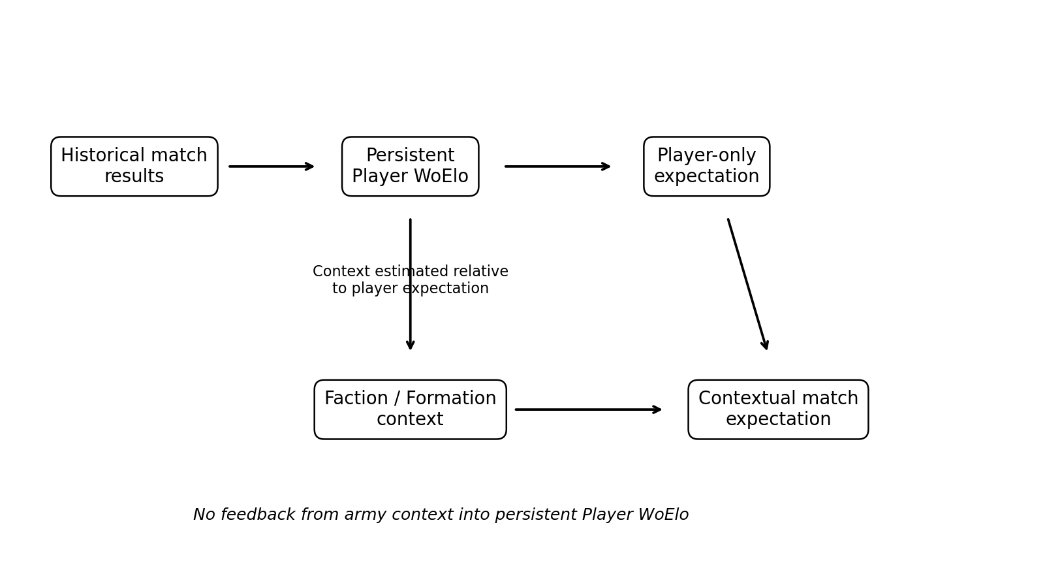
Figure 1. WoElo model architecture. Persistent player ratings are updated from match results; army context is used for contextual analysis and prediction but does not feed back into the persistent player rating.

Player WoElo Rating
The foundation of WoElo is a sequential Elo-style player rating. Each player is assigned a numerical rating representing their demonstrated performance relative to the wider tournament population.
A player entering the dataset without an existing rating begins with a WoElo of 300. This value is a starting point rather than an assumption that the player possesses a known level of ability. As the player completes games, their rating changes according to their results and the ratings of their opponents.
The system is zero-sum at the level of an individual match. A player's rating increases when their actual result exceeds the result expected from the relative ratings of the two players and decreases when their result falls below expectation. Consequently, defeating a substantially stronger opponent produces a larger positive adjustment than defeating a substantially weaker opponent, while losing to a weaker opponent results in a larger negative adjustment than losing to a stronger one.
WoElo is therefore not intended to measure a player's win rate directly. Two players with identical win rates may receive different WoElo ratings if those results were achieved against opponents of substantially different strength.
Importantly, the player rating is updated using player ratings alone. Estimated Faction and Battle Formation effects are not incorporated into the update of the persistent player rating. This maintains a distinction between the historical performance of the player and contextual characteristics of the army they are currently using.

Expected Match Score
Before each game, WoElo calculates the expected score for each player from the difference between the two players' pre-game ratings.
For player (A) against player (B), the expected score is:
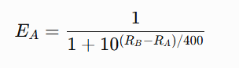
where:
(EA) is the expected score for player (A);
(RA) is player (A)'s pre-game WoElo;
(RB\) is player (B)'s pre-game WoElo.
The expected score ranges from 0 to 1. Two equally rated players therefore each receive an expected score of 0.5. As the rating difference increases, the higher-rated player's expected score increases and the lower-rated player's expected score decreases.
The denominator of 400 controls the relationship between rating difference and expected score. It is retained as the scaling parameter in the production WoElo model. Alternative scaling values were examined during robustness testing and are discussed later in this paper.
The expected score should be interpreted as a probabilistic expectation rather than a prediction that a particular player will win. For example, an expected score of 0.70 indicates that the model assigns the higher-rated player substantially greater expectation than their opponent across comparable games; it does not imply certainty about the outcome of an individual match.

Updating Player WoElo
Following each game, the player's WoElo is updated according to the difference between their actual and expected result.
Actual match scores are represented as:
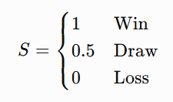
The updated rating is calculated as:
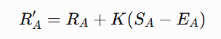
where (R'A) is the player's new rating, (RA) is their pre-game rating, (SA) is their actual match score, (EA) is their expected score, and (K) determines the magnitude of the rating adjustment.
WoElo uses a two-stage (K)-factor:
K = 40 while a player has fewer than 30 prior recorded games;
This higher early K-factor also provides the principal cold-start mechanism for new players. A player with no existing WoElo record enters at 300 and is allowed to move more rapidly during their first 30 recorded games. After that point, the lower K-factor reduces the influence of individual results and provides greater rating stability.
The higher initial value allows ratings to respond more quickly while relatively little information is available about a player. Once a larger match history has accumulated, the lower value reduces the influence of individual results and produces a more stable rating.
Games are processed chronologically. A player's rating before a game therefore incorporates only results recorded before that game. Results occurring later in the dataset cannot influence the expectation assigned to an earlier match.
This chronological updating is important both to the interpretation of WoElo as a developing player rating and to the validation framework described in Section 2.

Estimating Faction Performance
Raw Faction win rate describes the proportion of observed results won by players using that Faction. It does not account for differences in the strength of the players producing those results.
WoElo therefore estimates a player-skill baseline for each Faction.
For every eligible non-mirror game involving a Faction, the player-only WoElo model provides an expected score based on the pre-game ratings of the two players. These expectations can be aggregated across the Faction's games to estimate the results that would have been expected given the particular players and opponents represented in the sample.
The difference between observed performance and player-expected performance provides the basis for estimating a Faction-level residual.
Conceptually:
Faction residual=Observed performance−Player-expected performance
The calculation is performed on the Elo/log-odds scale rather than by simply subtracting percentage-point win rates. This allows the resulting Faction adjustment to remain compatible with the logistic structure used elsewhere in WoElo.
A positive Faction adjustment indicates that players using the Faction collectively performed above the expectation generated from player strength alone. A negative adjustment indicates performance below that expectation.
This should not be interpreted as a causal estimate of the intrinsic strength of the Faction. The residual may also contain the influence of list construction, Battle Formation selection, matchup composition, event structure and other variables not explicitly represented by the model. It is instead an estimate of the additional predictive information associated with Faction after accounting for the measured strength of the players involved.

Estimating Battle Formation Performance
Battle Formation is treated as an additional contextual level beneath Faction.
As with Faction performance, the purpose is not simply to identify which Formations possess the highest raw win rates. Players choosing different Formations may themselves differ systematically in strength, meaning that part of an observed Formation win rate may reflect the players using it rather than the Formation alone.
For each eligible non-mirror game, observed Formation performance is therefore compared with the expected performance generated from the players involved.
The resulting skill-adjusted Formation performance can be expressed on the Elo scale as a Formation bias. Positive values indicate performance above player expectation, while negative values indicate performance below expectation.
Before shrinkage, the raw Formation bias B is calculated as the difference between the observed and player-expected performance on the Elo/log-odds scale:
B = 400 log10(O / (1 − O)) − 400 log10(E / (1 − E))
where O is the observed score rate for the Formation across eligible non-mirror games and E is the mean player-only expected score across those same games. In implementation, extreme observed rates of 0 or 1 are bounded before the log-odds transformation to avoid undefined values. The resulting raw bias is also bounded to ±400 WoElo before sample-size shrinkage is applied.
Formation estimates are particularly susceptible to sampling variation because many Formations are represented by relatively few games. WoElo therefore applies shrinkage towards a neutral effect.
For a Formation with observed bias (B) and (n) eligible games, the confidence-adjusted Formation bias is:
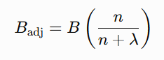
where $λ$is the shrinkage parameter.
The production model uses:
$λ=100$
Consequently, estimates based on small samples are pulled strongly towards zero, while estimates supported by larger numbers of games retain a greater proportion of their observed effect.
The purpose of this adjustment is not to declare small-sample Formations balanced. Rather, it reflects greater uncertainty about whether an extreme observed result represents a persistent Formation effect or sampling variation.

Contextual Match Expectation
The persistent player rating and contextual army adjustments can be combined when the objective is to estimate the expected outcome of a particular match.
For player (A) against player (B), a contextual expectation may be expressed as:
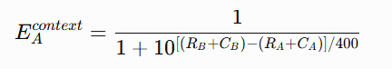
where (RA) and (RB) are the players' WoElo ratings and (CA) and (CB) represent the relevant contextual army adjustments.
In the Formation model, the contextual adjustment is derived from the confidence-adjusted Formation effect associated with each player's Faction and Battle Formation.
This produces two conceptually distinct expectations within WoElo:
Player-only expectation asks what result would be expected from the historical performance of the two players.
Contextual expectation asks whether incorporating information about the armies being used improves that expectation.
This distinction is central to the architecture of WoElo. Contextual effects may improve the prediction of an individual match without becoming part of the player's persistent rating.
Following the match, the player's WoElo update therefore continues to use the player-only expected score described in Sections 3.2 and 3.3. The Formation adjustment does not feed back into the player's persistent rating.
This prevents a player's rating from being mechanically increased or decreased because the model considers their chosen army stronger or weaker. Whether allowing such feedback improves predictive performance was examined separately during model development and is reported in the validation results.

Worked example: separating player expectation from army context
Suppose Player A and Player B both enter a match with WoElo 400. The player-only model therefore assigns each an expected score of 0.50.
If Player A's Formation carries a confidence-adjusted contextual value of +40 WoElo and Player B's carries -20, the contextual model sees an effective difference of 60 points. Using the standard 400-point logistic scale, Player A's contextual expected score becomes approximately 0.585 and Player B's approximately 0.415.
The distinction is important: the 58.5% contextual expectation may improve interpretation of this particular match, but the subsequent persistent player-rating update still uses the original player-only 50:50 expectation. Army context informs the match analysis without being absorbed into the player's WoElo.

Interpretation of Model Outputs
The WoElo framework produces several related measures which answer different questions and should not be interpreted interchangeably.
Observed Win Rate describes what happened in the recorded tournament sample. It remains the most direct descriptive measure of Faction performance but does not account for differences in player strength.
Player Expected Win Rate describes the performance that would have been expected from the players involved based on their pre-game WoElo ratings and the opponents they faced.
Skill-Adjusted Performance compares observed results with that player expectation. It asks whether a Faction or Battle Formation performed above or below what would have been expected from its player population.
Player WoElo is the persistent sequential rating assigned to an individual player from their historical match results. It should not be interpreted as a rating of the army they currently use.
These measures are intended to complement rather than replace one another. A high raw win rate may coincide with a strong player population, a positive contextual effect, or both. Conversely, a Faction with an unremarkable raw win rate may have been used by a relatively weak player population while nevertheless performing above the expectation generated from those players.
For this reason, WoElo does not attempt to replace raw win rate with a single alternative measure of balance. Instead, it provides additional context for interpreting the results observed in tournament play.

Validation Framework and Model Comparison
The purpose of validating WoElo is not simply to demonstrate that player ratings correlate with match outcomes. A rating system constructed from historical results would be expected to show some relationship with those same results. The more important question is whether information derived from previous games improves the prediction of future, previously unseen games.
WoElo was therefore evaluated using a temporal holdout design. Model components were developed using historical tournament information available through the end of July 2026. Their ability to predict games played during August 2026 was then evaluated without allowing August outcomes to influence the parameters being tested.
This approach provides a more demanding test than measuring goodness-of-fit on the data used to construct the model. It also more closely reflects the intended practical use of WoElo: using information known at one point in time to interpret or predict tournament results occurring subsequently.

Temporal Holdout
The primary validation period consists of tournament games played during August 2026.
This should not be interpreted as a simple July-training/August-testing split. Player WoElo ratings incorporate the historical tournament record available before the holdout, while contextual information entering the validation period is estimated only from information available through the end of July. August therefore functions as a future period against which the information available at the end of July is evaluated.
Games within August were processed chronologically. Player WoElo ratings could therefore develop during the holdout period as new results became available, reflecting how the system would operate in practice. However, contextual parameters being evaluated as part of the holdout comparison were not retrospectively re-estimated using later August outcomes.
This distinction prevents future information from leaking into earlier predictions while allowing the persistent player-rating system to operate sequentially.
Once August results had been examined and used to propose a new model specification or parameter value, August could no longer be regarded as an independent test of that particular change. Such analyses are therefore identified as exploratory robustness tests rather than primary holdout validation.

Unit of Evaluation
Tournament data are stored from the perspective of each participating player, meaning that a physical game may be represented by two reciprocal records: one from each player's perspective.
Using both rows as though they represented independent games would artificially increase the apparent sample size. Primary inferential comparisons therefore use one observation per physical match.
Reciprocal records remain useful for descriptive analyses, including calibration plots in which the predicted probability from each player's perspective can be examined. However, uncertainty estimates and paired comparisons between competing models are calculated at the physical-match level.
This ensures that statistical inference reflects the number of independent games rather than the number of database rows.

Primary Evaluation Metric
Predictive performance is evaluated primarily using the Brier score.
For a set of (N) games, the Brier score is:
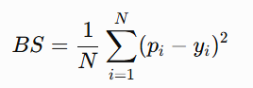
where (pi) is the predicted score for observation (i), and (yi) is the observed result.
For decisive games, the observed result is coded as 1 for a win and 0 for a loss. Draws are represented by an observed score of 0.5, consistent with the scoring convention used in the WoElo rating system.
A lower Brier score indicates better probabilistic predictive performance.
The Brier score is preferred to simple prediction accuracy because WoElo produces probabilistic expectations rather than binary winner selections. A model assigning a player a 51% expectation and a model assigning the same player a 90% expectation may both identify the same player as the more likely winner, but the strength of those predictions is substantially different. The Brier score rewards appropriately confident correct predictions while penalising confidently incorrect predictions.
The principal model comparisons therefore assess whether adding contextual information reduces Brier score relative to the player-only WoElo model.

Models Compared
Four principal specifications were compared on like-for-like holdout games.
Player Only
The baseline WoElo model uses only the pre-game ratings of the two players:
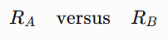
This establishes how much predictive information is available from persistent player performance alone.
Player + Faction
The second specification supplements player WoElo with estimated Faction-level contextual effects.
This tests whether knowledge of the Factions being used provides predictive information beyond that already contained in the identities and historical performance of the players.
Player + Battle Formation
The third specification supplements player WoElo with the confidence-adjusted Battle Formation effects described in Section 3.
This tests whether the more specific army configuration represented by Battle Formation provides additional predictive information beyond player strength.
Player + Faction + Battle Formation
The final specification combines player strength with both Faction and Battle Formation information, with the Formation term represented as an additional contextual effect rather than simply duplicating information already captured at Faction level.
This specification is constructed hierarchically rather than as a joint regression. A Faction-level adjustment is estimated first from performance relative to the player-only expectation. Battle Formation is then represented as a residual contextual term within that Faction, so that the Formation component captures additional information beyond the broader Faction adjustment rather than duplicating it. The resulting Faction and residual Formation terms are then added to the players' WoElo ratings when constructing the combined contextual match expectation.
Comparisons are performed using the same eligible games wherever possible. This prevents a model from appearing superior merely because missing contextual information causes it to be evaluated against a different set of matches.

Paired Model Comparison
A lower Brier score for one model does not by itself establish that the observed difference is robust. Small differences may arise because of the particular collection of matches appearing in the holdout period.
Model comparisons are therefore performed on a paired basis.
For each physical match, the Brier loss generated by one model can be compared directly with the loss generated by another model:
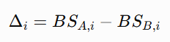
The mean paired difference indicates whether one specification tends to produce lower prediction error across the same matches.
Because tournament results do not necessarily satisfy the assumptions required for simple parametric uncertainty estimates, bootstrap resampling is used to examine the stability of these differences.
Physical matches are resampled with replacement, and the mean paired Brier difference is recalculated for each bootstrap sample. The resulting distribution is used to estimate a 95% bootstrap interval around the observed difference and the proportion of resamples in which one model outperforms the other.
Resampling is performed at the physical-match level rather than the reciprocal-row level so that the same game is not treated as two independent observations.

Calibration
Predictive discrimination alone does not establish that predicted probabilities are appropriately scaled. WoElo is therefore also assessed for calibration.
Predictions are grouped into probability bands and compared with the outcomes actually observed within those bands. A well-calibrated model should, over a sufficiently large sample, produce outcomes that broadly correspond to its predicted probabilities.
For example, players assigned approximately a 70% expected score should collectively achieve approximately 70% of the available match score if the model is well calibrated.
Calibration analysis therefore addresses a different question from overall Brier score. A model may correctly rank stronger and weaker players while still producing probabilities that are systematically too conservative or too extreme.
A supplementary logistic calibration model is also fitted to assess the relationship between predicted log-odds and observed results. The resulting calibration slope provides an indication of whether WoElo probabilities are appropriately dispersed.
A slope close to 1 is consistent with appropriate probability scaling. A slope greater than 1 indicates that predicted probabilities are generally too conservative, while a slope below 1 indicates predictions that are too extreme.
Because calibration parameters estimated from the August holdout are themselves informed by August outcomes, any recalibration suggested by this analysis is treated as exploratory rather than incorporated retrospectively into the validated production model.

Sensitivity and Robustness Analysis
Several modelling choices within WoElo require parameter values or structural decisions. Robustness analyses were therefore conducted to determine whether the main conclusions depended strongly on any single choice.
These analyses included variation in:
- the Elo scaling denominator;
- the number of games before the lower \(K\)-factor is applied;
- the shrinkage parameter used for Battle Formation effects;
- the treatment and weighting of Formation effects at different player-rating gaps; and
- whether contextual Formation information should influence subsequent player-rating updates.
These tests serve two purposes. First, they identify whether the production model occupies a reasonably stable region of parameter space rather than depending on a narrowly optimised value. Second, they provide evidence about alternative model structures that may warrant investigation in future validation periods.
Where an alternative parameter or model structure was proposed after examining August results, its performance during August is reported as exploratory. An apparent improvement under those circumstances is not treated as independent evidence that the alternative will perform better on future data.
This distinction is particularly important where parameters can be tuned continuously. Selecting the value that minimises prediction error on the holdout and then reporting that same error as validation would effectively convert the holdout period into additional development data.

Skill and Contextual Information
In addition to comparing complete predictive models, the analysis examines the relative predictive information associated with player strength and army context.
This is performed by comparing models containing different combinations of player and contextual information against a common baseline. The resulting improvement in predictive error can then be decomposed to estimate how much of the information captured by the model is associated with player ratings and how much is associated with Battle Formation.
Because player strength and army choice are not experimentally assigned and may be correlated, this analysis is explicitly predictive rather than causal.
A finding that player WoElo accounts for a large proportion of the model's predictive improvement does not imply that the same proportion of match outcomes is "caused" by player skill. Similarly, incremental predictive information associated with Formation should not be interpreted as a direct causal estimate of the effect of army selection.
The purpose is instead to quantify how much additional information each variable contributes to prediction within the observed tournament population.

Skill-Matched Faction Analysis
A separate robustness analysis examines the extent to which raw Faction win rates are sensitive to differences in the player populations using each Faction.
For each Faction, subsets of games are constructed in which the WoElo difference between the two opposing players is restricted. Faction performance within these more closely skill-matched games can then be compared with performance in the full sample.
However, restricting games by player-rating difference necessarily reduces sample size. Raw win rates would therefore be expected to move to some degree even if the removed games contained no systematic player-strength effect.
To distinguish this sampling effect from genuine sensitivity to player composition, the observed movement is compared with randomly selected subsets of equivalent size drawn from the same Faction data.
This provides a reference distribution for the amount of movement that would be expected simply from analysing fewer games.
The same procedure can then be applied to skill-adjusted Faction estimates. If raw win rates are materially influenced by the strength composition of the player population, while adjusted estimates successfully account for some of that influence, the adjusted estimates should be less sensitive to skill matching than the unadjusted results.

Interpretation of Validation Evidence
No single validation statistic is treated as sufficient evidence for adopting a model change.
A proposed addition to WoElo is considered more credible where it:
- improves prediction on previously unseen games;
- does so on a like-for-like sample;
- shows a reasonably stable improvement under paired resampling;
- remains useful across plausible parameter choices; and
- has a clear interpretation consistent with the intended separation between player performance and army context.
Conversely, additional complexity is not retained merely because it produces a numerically lower error in one particular sample.
This conservative approach is deliberate. The objective of WoElo is not to maximise retrospective fit, but to construct a transparent and reproducible framework that can continue to be tested as additional Age of Sigmar tournament results become available.

Results
The August 2026 temporal holdout was used to evaluate whether information about player strength, Faction and Battle Formation improved prediction of previously unseen tournament games.
The principal comparisons were conducted on a common sample of 2,691 physical matches for which the information required by each model was available. Using one record per physical match prevents reciprocal player-perspective records from artificially increasing the effective sample size.
Across this sample, player WoElo provided the majority of the predictive information captured by the models. Battle Formation information produced a small additional improvement beyond player strength alone, while the addition of Faction-level information did not improve predictive performance to the same extent.

Holdout Predictive Performance
The four principal model specifications were evaluated using Brier score, where lower values indicate better probabilistic prediction.
Model | Brier Score
Player Only | 0.201775
Player + Faction | 0.202168
Player + Battle Formation | 0.200797
Player + Faction + Battle Formation | 0.201602

The Player + Battle Formation model produced the lowest Brier score of the four principal specifications.
Relative to the Player Only model, incorporating Battle Formation reduced Brier score by approximately 0.00098. The magnitude of this improvement is small, indicating that most of the predictive information was already contained within player WoElo.
Adding Faction information alone did not improve prediction. The Player + Faction specification produced a slightly higher Brier score than Player Only. Similarly, combining Faction and Formation information produced a lower Brier score than Player Only, but did not outperform the simpler Player + Formation specification.
These results suggest that Battle Formation contains a small amount of incremental predictive information beyond player strength, while the Faction-level adjustment does not provide the same improvement in match prediction within this holdout sample.
This result does not imply that Faction has no relationship with tournament performance. The predictive comparison asks the narrower question of whether adding Faction information improves individual match prediction after player WoElo is already known.

Paired Bootstrap Comparison
Because the difference between Player Only and Player + Formation was numerically small, paired bootstrap resampling was used to assess how consistently the improvement appeared across different resamples of the August physical matches.
For each bootstrap sample, physical matches were sampled with replacement and the mean difference in Brier loss between the two models was recalculated.
For Player + Formation minus Player Only, the mean paired difference was approximately:
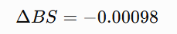
with a 95% bootstrap interval of approximately:
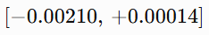
Approximately 95.9% of bootstrap resamples favoured the Player + Formation model.
The interval nevertheless crosses zero. The result should therefore be interpreted as suggestive rather than conclusive evidence that Formation information improves prediction beyond player WoElo.
Comparisons with the other contextual models were more consistently favourable to Player + Formation. Approximately 99.6–99.7% of bootstrap resamples favoured Player + Formation over the Faction-only and combined Faction-plus-Formation specifications.
The overall evidence therefore supports retaining Formation as a contextual analytical variable, while also indicating that its incremental predictive contribution is substantially smaller than that of player strength.

Relative Predictive Contribution of Player and Formation Information
To investigate the relative amount of predictive information associated with player strength and Battle Formation, the improvement over a neutral 50:50 prediction baseline was decomposed between the two sources of information.
The neutral baseline produced a Brier score of approximately 0.24638. This improved to approximately 0.20178 using Player Only and 0.20080 using Player + Formation.
A Shapley-style decomposition of the captured predictive improvement attributed approximately:
- 98.3% to player information; and
- 1.7% to Battle Formation information.
These percentages describe the relative contribution of the two information sources to predictive improvement within this model and sample. They must not be interpreted as estimates that 98.3% of game outcomes are caused by player skill or that Formation determines 1.7% of results.
The decomposition instead indicates that, for predicting tournament games in the August holdout, knowledge of the players involved was substantially more informative than knowledge of their Battle Formations.

Formation Information at Different Player-Skill Gaps
The relative contribution of Formation was not constant across all matches.
When players were relatively closely matched in WoElo, Formation information represented a larger proportion of the predictive improvement. As the difference in player rating increased, the incremental information provided by Formation declined substantially.
The approximate Formation share of captured predictive improvement was:
Absolute WoElo Difference | Formation Share
0-25 | 33%
26-50 | 29%
51-100 | 6%
101+ | ~0%

When games were grouped more broadly, approximately 31% of captured predictive improvement in matches between players within 50 WoElo points was associated with Formation information, compared with approximately 69% associated with player information.
For matches with a WoElo difference greater than 50 points, approximately 99.4% of captured predictive improvement was associated with player information and approximately 0.6% with Formation.
This analysis suggests that army context may provide its greatest predictive value when the players involved are relatively closely matched. When player-strength differences become larger, the player-rating signal increasingly dominates prediction.
As with the overall decomposition, these figures describe predictive information rather than causal influence.
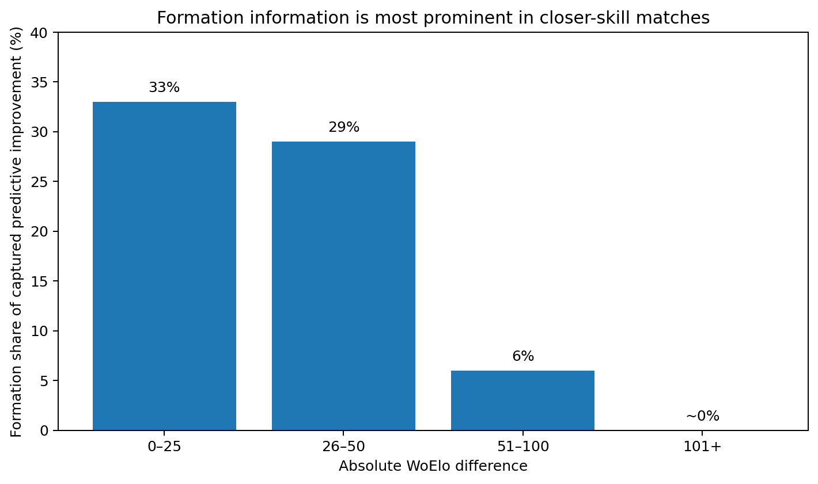
Figure 2. Approximate Battle Formation share of captured predictive improvement by absolute WoElo difference. Values describe predictive information within the tested model, not causal influence on match outcomes.

Sensitivity of Raw Faction Win Rates to Player Composition
The skill-matched analysis examined whether raw Faction win rates changed when attention was restricted to games between more closely rated players.
Across Factions, the mean absolute movement in raw win rate after restricting the analysis to games with a WoElo difference of no more than 75 points was approximately 3.81 percentage points.
However, restricting the sample necessarily reduces the number of games available. To estimate how much movement might occur from sample reduction alone, random subsets of equivalent size were repeatedly drawn from the full Faction samples.
These random subsets produced an average absolute movement of approximately 2.96 percentage points.
The movement observed after skill matching was therefore larger than would typically be expected from reducing sample size alone. The corresponding simulation-based probability was approximately:
$p = 0.039$
This provides evidence that the composition of the player population contributes measurably to variation in observed raw Faction win rates.
The result does not imply that player strength explains all differences between Faction win rates. Instead, it demonstrates that raw win rate is sensitive to who is producing the results, supporting the use of player-strength information when interpreting Faction performance.

Stability of Skill-Adjusted Faction Estimates
The same skill-matching procedure was applied to the WoElo-adjusted Faction estimates.
The mean absolute movement in the adjusted estimates was approximately 1.22 percentage points, compared with approximately 1.35 percentage points in random same-size subsets.
Approximately 74% of random simulations produced movement at least as large as that observed after skill matching.
Unlike raw win rate, therefore, the adjusted Faction estimates did not show evidence of unusual movement when the player populations were more closely matched.
Taken together, Sections 5.5 and 5.6 provide complementary evidence. Raw Faction win rates moved more under skill matching than would ordinarily be expected from sample reduction, while the skill-adjusted estimates remained comparatively stable.
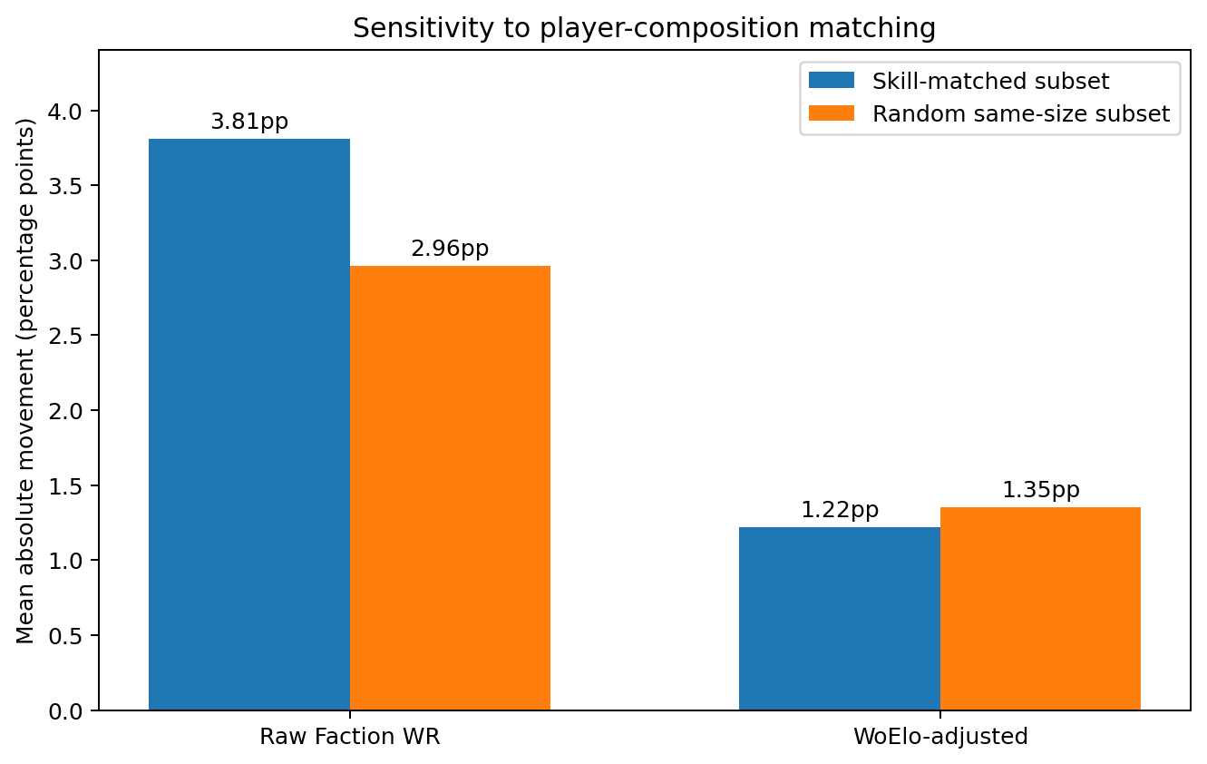
Figure 4. Mean absolute movement in Faction-level estimates after restricting games to players within 75 WoElo points, compared with random subsets of equivalent size. Raw win rates moved more under skill matching than expected from sample reduction alone, whereas WoElo-adjusted estimates did not.
This is consistent with the intended purpose of the adjustment: reducing the sensitivity of Faction-level estimates to differences in the strength of the players represented in the sample.
No individual Faction's full-sample versus skill-matched change was sufficiently precise to establish a clear faction-specific effect at conventional significance levels. The result should therefore be interpreted primarily as evidence about the behaviour of the aggregate methodology rather than as evidence concerning any particular Faction.

Probability Calibration
Calibration analysis showed that player-only WoElo successfully distinguished between stronger and weaker match expectations, but its probabilities were generally too conservative.
Observed outcomes became progressively more favourable as predicted probability increased, demonstrating that the rating differences contained meaningful information about match outcomes. However, players given low predicted expectations tended to perform worse than predicted, while players given high expectations tended to perform better than predicted.
The descriptive calibration results were approximately:

Predicted Band | Mean Prediction | Observed Result
0-10% | 8.4% | 0.0%
10-20% | 16.0% | 6.9%
20-30% | 25.7% | 17.2%
30-40% | 35.4% | 29.0%
40-50% | 45.4% | 40.3%
50-60% | 54.4% | 59.1%
60-70% | 64.6% | 71.0%
70-80% | 74.3% | 82.8%
80-90% | 84.0% | 93.1%
90-100% | 91.6% | 100.0%

A logistic calibration analysis produced a slope of approximately:
$1.573$
with an approximate 95% confidence interval of:
$[1.465, 1.681]$
while the calibration intercept was close to zero.
The near-zero intercept indicates little evidence of an overall directional bias towards either player. The slope greater than 1 indicates that the predicted probabilities were under-dispersed: WoElo correctly identified differences in expected player performance but tended to underestimate their magnitude.
In practical terms, WoElo generally separated stronger from weaker players in the correct direction, but not strongly enough. Players given high expectations tended to achieve even higher results than predicted, while players given low expectations tended to perform even worse. The model therefore compressed probabilities too closely towards 50%.
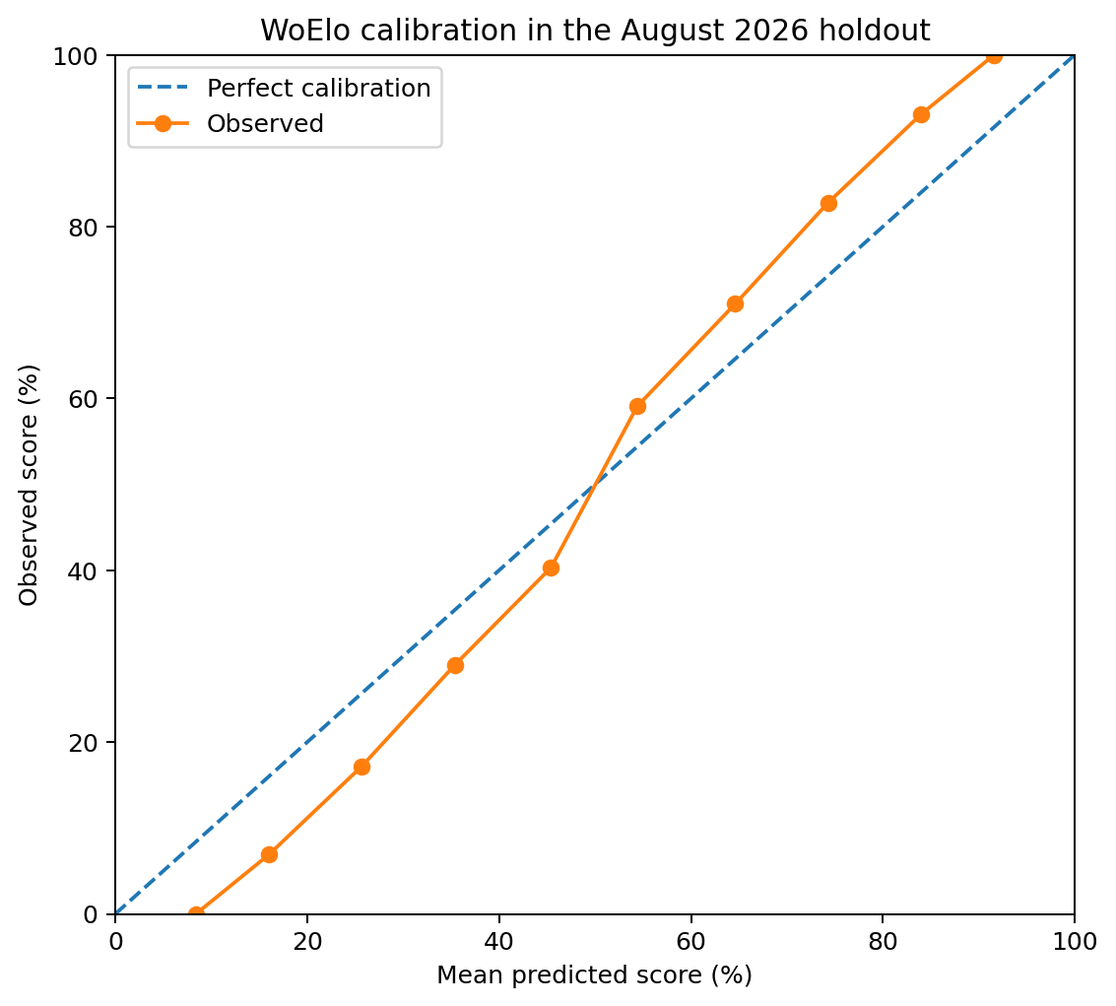
Figure 3. Calibration of player-only WoElo predictions in the August 2026 holdout. The dashed diagonal represents perfect calibration; the observed curve shows that realised outcomes were generally more extreme than the model probabilities.
A post-hoc recalibration fitted to the August data improved Brier score, and the estimated slope corresponds approximately to a narrower effective Elo scaling denominator. However, because this recalibration was derived using the holdout results themselves, it cannot be regarded as independently validated and was not incorporated into the production model.

Parameter Sensitivity
Robustness testing examined whether the principal findings depended heavily on individual parameter choices.
For the Battle Formation shrinkage parameter, predictive performance was relatively stable across a broad region around the production value of $λ=100$.

Formation λ | Brier Score
25 | 0.201928
50 | 0.201233
75 | 0.201028
100 | 0.200974
125 | 0.200977
150 | 0.201004
200 | 0.201079
300 | 0.201225

The broad similarity between values around 75–150 suggests that the Formation result is not dependent on a narrowly optimised shrinkage value.
Accordingly, λ=100 is retained as a pragmatic production value within a broad region of similar holdout performance, rather than as a uniquely identified optimum. Its purpose is regularisation: a simple form of partial pooling towards a neutral Formation effect as sample size decreases.
Testing of the high-K development period similarly indicated a relatively broad region of comparable performance. Although some alternative transition points produced marginally lower error in reconstruction tests, differences were small and did not provide sufficient evidence to replace the pre-existing 30-game threshold.
Alternative Elo scaling denominators were also examined. A smaller denominator appeared favourable when applied post hoc to the existing ratings, consistent with the calibration results. However, when the rating system was rebuilt consistently using the alternative scale, the apparent advantage was substantially reduced.
The production denominator of 400 was therefore retained pending independent future validation.

Exploratory Alternative Formation Models
The finding that Formation information appeared most useful when players were closely matched motivated an exploratory model in which the Formation adjustment decreased as the absolute WoElo difference between the players increased.
The Formation weight was defined as:
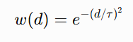
where (d) is the absolute player WoElo difference and $τ$controls the rate at which Formation influence declines.
Exploratory testing suggested that values around $τ$=200 produced lower Brier scores than applying the full Formation adjustment uniformly to all matches. A value around $τ$=208 produced the lowest error examined, with a Brier score of approximately 0.20070.
This was marginally lower than the approximately 0.20080 obtained from the pre-specified constant Formation model.
However, the weighting function and its parameter were proposed and selected after examining the August holdout. The improvement is therefore not an independently validated result.
The gap-weighted model was consequently not adopted into the production WoElo specification. It instead represents a pre-specified hypothesis that can be tested against a future holdout period.

Formation Feedback into Player Ratings
A further exploratory test examined whether Formation-adjusted match expectations should be used when updating subsequent player WoElo ratings.
Under this alternative, a player achieving a result while using an estimated weaker Formation would receive a different rating adjustment from the same result achieved using an estimated stronger Formation.
The original architecture, in contrast, updates persistent player WoElo using player-only expectation and reserves Formation information for contextual analysis.
Testing did not provide evidence that Formation feedback improved prediction. Using the exploratory gap-weighted Formation model, the original no-feedback architecture produced a Brier score of approximately 0.200698, compared with approximately 0.200731 when Formation was allowed to influence subsequent player ratings.
The difference was extremely small and the bootstrap comparison provided no convincing evidence in favour of the more complex specification.
Additional (K)-factor sensitivity testing similarly failed to produce a stable advantage for Formation feedback.
The production architecture therefore retains the simpler separation:
Player WoElo = persistent player performance
Formation = contextual match adjustment
This separation is both easier to interpret and better supported by the available validation evidence.

Summary of Results
The August holdout produced five principal findings.
- Player WoElo contains substantial predictive information. Player strength accounts for the overwhelming majority of the improvement over neutral match prediction captured by the tested models.
- Battle Formation contributes additional information, but the effect is comparatively small. The pre-specified Player + Formation model achieved the lowest Brier score among the principal model specifications, although its bootstrap interval relative to Player Only crossed zero.
- Formation information appears most relevant when players are closely matched. Its incremental predictive contribution declines rapidly as the difference in player WoElo increases.
- Raw Faction win rates are measurably sensitive to player composition. Skill matching produced greater movement in raw win rates than expected from equivalent random reductions in sample size, while skill-adjusted estimates were more stable.
- WoElo probabilities are conservative. Player-rating differences discriminate meaningfully between match outcomes, but the observed calibration slope indicates that the production model understates the magnitude of those differences.
The exploratory analyses identify several potential improvements, particularly probability recalibration and rating-gap-dependent Formation weighting. However, because these hypotheses were developed using the August holdout, they require evaluation against future unseen tournament results before they can be considered validated changes to the production model.

Discussion
The purpose of WoElo is not to replace tournament win rate with a more complicated statistic. Raw win rate remains an important descriptive measure of what occurred within a tournament population. The results of this study instead demonstrate that win rate should be interpreted alongside information about the players who produced it.
Three findings are particularly important. First, player WoElo contains substantially more predictive information about individual match outcomes than the army-context variables examined in this study. Second, Battle Formation provides a small amount of additional predictive information, particularly when players are relatively closely matched. Third, raw Faction win rates are measurably sensitive to the composition of the player population, while estimates adjusted for player strength are less sensitive to that composition.
Together, these findings support a layered approach to tournament analysis in which observed results, player strength and army context are considered separately rather than collapsed into a single measure.

Raw Win Rate Remains Useful
The results should not be interpreted as an argument against the use of raw win rate.
Raw win rate answers a simple and important descriptive question:
What proportion of the recorded games did players using this Faction win?
WoElo does not provide a better answer to that question because it is attempting to answer a different one.
The difficulty arises when raw win rate is interpreted directly as a measure of underlying Faction strength. Such an interpretation implicitly assumes that differences between the players using different Factions are either negligible or sufficiently balanced across the sample.
The skill-matching analysis presented in Section 5 provides evidence that this assumption does not always hold. Restricting games to more closely matched players changed raw Faction win rates by more than would ordinarily be expected from the associated reduction in sample size.
Raw win rate therefore reflects the combined outcome of several influences, including player strength, army choice, Battle Formation, matchup composition and sampling variation.
This does not make raw win rate misleading. It makes it descriptive rather than explanatory.

Player Population as a Source of Context
One of the central findings of the analysis is that the player populations associated with different Factions cannot necessarily be treated as interchangeable.
If stronger players are disproportionately represented within one Faction, that Faction may record a higher raw win rate even if its rules provide no additional advantage. Conversely, a Faction used disproportionately by less successful players may record a lower raw win rate even where its underlying competitive potential is greater than the raw result suggests.
The reason for these differences in player composition is not established by WoElo and need not be the same for every Faction. Competitive players may favour particular armies, experienced specialists may remain committed to less popular Factions, newly released armies may attract different populations, and accessibility or model ownership may influence participation.
WoElo does not attempt to model these selection processes.
Instead, the player-expected baseline asks a narrower question:
Given the demonstrated performance of the players using this Faction and the opponents they faced, what level of performance would have been expected?
Observed performance can then be interpreted relative to that baseline.
This provides additional context without requiring an assumption about why a particular group of players chose the Faction.

Player Skill Dominates Match Prediction
The predictive decomposition indicates that player information accounted for approximately 98% of the improvement captured by the Player + Formation model over a neutral prediction baseline.
This is a large difference, but its interpretation requires care.
It does not demonstrate that player skill causes 98% of the outcome of an Age of Sigmar game. The analysis is observational, and WoElo itself is derived from previous match outcomes. The decomposition describes the information available to the predictive model, not the causal contribution of individual factors to winning.
Nevertheless, the result demonstrates that knowing the historical performance of the players is substantially more useful for predicting individual tournament games than knowing their Battle Formations alone.
This has an important implication for aggregate tournament statistics. Analyses that compare armies while ignoring differences between the players using them omit a variable with substantial predictive information.

The Role of Battle Formation
Although player information dominated overall prediction, Battle Formation was not irrelevant.
The Player + Formation specification produced the strongest predictive performance among the principal pre-specified models. The improvement over Player Only was small, and the bootstrap interval included zero, meaning the evidence should be regarded as suggestive rather than definitive.
More importantly, the value of Formation information appeared to depend upon the relative strength of the players.
When players were closely matched, Formation accounted for a substantially greater share of captured predictive improvement. As the WoElo difference between players increased, its incremental contribution rapidly diminished.
This pattern is intuitively plausible. When two players have substantially different historical performance, player strength provides a strong predictive signal. When their demonstrated performance is similar, contextual differences between their armies have greater opportunity to contribute useful information.
However, the rating-gap-dependent Formation model was developed after examining the August holdout. The pattern therefore represents a hypothesis for future testing rather than a validated production-model feature.
The production model consequently retains the simpler confidence-adjusted Formation effect pending evaluation against new data.

Faction and Formation Measure Different Things
The different predictive performance of Faction and Battle Formation should not be interpreted as contradictory. Faction is a relatively broad analytical category within which multiple Battle Formations, list constructions and player populations are combined. If meaningful differences exist within a Faction, aggregation at Faction level may dilute those differences sufficiently that the Faction label contributes little additional predictive information once player strength is known.
Battle Formation provides a more granular description of army context and may therefore retain information that is obscured by Faction-level aggregation. The present analysis does not establish that this is the mechanism responsible for the observed difference, but the result provides a clear reason to examine army construction below headline Faction win rate rather than assuming that Faction is necessarily the most informative unit of analysis.
Faction-level and Formation-level analyses serve different purposes.
Faction is the principal level at which Age of Sigmar balance is commonly discussed and at which many rules, warscrolls and points structures are organised. Faction-level statistics therefore remain important for describing the tournament environment.
Battle Formation, however, provides more specific information about the configuration being used within a Faction. If competitive performance is concentrated within particular builds, a broad Faction label may contain less predictive information than the more specific Formation choice.
The failure of the Faction adjustment to improve individual-match prediction therefore does not invalidate Faction-level analysis. Instead, it reinforces the distinction between describing aggregate tournament performance and optimising individual match prediction.
These are related but not identical statistical objectives.

Adjusted Win Rate Should Not Become a New Balance Threshold
A potential misuse of WoElo would be to replace conventional raw win-rate thresholds with equivalent thresholds applied to skill-adjusted win rate.
For example, replacing the statement that a Faction above a particular raw win rate is problematic with the same statement based solely on adjusted win rate would reproduce many of the limitations the framework is intended to address.
The adjusted estimate remains subject to sampling uncertainty, model assumptions, unmeasured contextual factors and variation in the tournament population. It is additional evidence, not an objective measurement of intrinsic army power.
The strongest interpretation therefore comes from considering several measures together.
A Faction with a high raw win rate, a confidence interval clearly above the wider field, performance above its player-strength baseline, strong tournament conversion and multiple successful Battle Formations presents a different evidential picture from a Faction with the same raw win rate generated by a small sample of unusually successful players.
WoElo is intended to make those distinctions visible.

Predictive Calibration and the Elo Scale
The calibration analysis provides evidence that WoElo's player ratings contain meaningful information but that the current probability transformation is conservative.
Players assigned high expected scores performed better than predicted, while players assigned low expected scores performed worse. The calibration slope of approximately 1.57 indicates that the model compresses predicted probabilities towards 50%.
This finding is consistent with the exploratory observation that a narrower effective Elo denominator can improve retrospective probability calibration.
However, changing the denominator has consequences beyond the probability transformation. Elo ratings themselves develop under the update mechanism, meaning that changing the scale and rebuilding the rating history is not equivalent to applying a simple post-hoc transformation to existing ratings.
The internally consistent denominator tests did not provide sufficient evidence to justify changing the production value of 400.
The calibration result should therefore be treated as a clear target for future validation rather than justification for retrospective optimisation.

Why Formation Does Not Feed Back into Player WoElo
Separating player rating from army context is both a conceptual and empirical decision.
Conceptually, WoElo is intended to provide a persistent measure of demonstrated player performance that can follow a player across Factions and Battle Formations. Allowing estimated army strength to alter the magnitude of subsequent player-rating changes would make the meaning of the rating dependent upon the contextual model used at that time.
Empirically, the exploratory Formation-feedback model did not produce a meaningful improvement in predictive performance.
Maintaining the separation therefore provides the simpler and more interpretable architecture:
Player results → Player WoElo
While:
Player WoElo + Army Context → Contextual Analysis
A player may therefore outperform expectation while using a Formation estimated to be strong or weak without that Formation estimate being mechanically removed from the player's subsequent rating change.
This preserves WoElo as a record of demonstrated competitive performance rather than an attempt to estimate an abstract army-independent measure of player ability.

Implications for Age of Sigmar Meta Analysis
The results suggest that tournament analysis benefits from moving beyond a single headline win-rate measure.
A more informative Faction assessment can distinguish at least four questions:
Observed performance: What percentage of games did the Faction actually win?
Uncertainty: How precisely has that performance been estimated given the number of games observed?
Player expectation: How well would the players using the Faction have been expected to perform based on their previous results?
Context-adjusted performance: Did the Faction or Formation perform above or below that expectation?
Other tournament measures can provide additional evidence. Representation indicates how much of the tournament population uses a Faction. Strong-record conversion measures whether game wins translate into 4-1 or 5-0 tournament performances. Formation analysis identifies whether success is distributed throughout a Faction or concentrated within particular configurations.
No individual measure answers the general question of whether an army is "balanced".
Instead, these measures describe different characteristics of the competitive environment.
This motivates the use of a Faction Dashboard rather than a single league table of win rates. The purpose of such a dashboard is not to obscure the raw result, but to place it alongside the information required to interpret it.

Implications for Balance Decisions
WoElo may also provide useful context when considering potential balance changes.
A Faction with an elevated raw win rate but a similarly elevated player-expected baseline may warrant different investigation from a Faction whose results substantially exceed the expectation generated from its players.
Likewise, strong Faction-level performance concentrated within a particular Battle Formation may suggest a different underlying pattern from broadly elevated performance across several Formations.
These distinctions do not prescribe a particular balance response.
Tournament data cannot independently determine whether points, warscroll rules, Battle Formations, battleplans or other game mechanics should be changed. Such decisions also require rules analysis, matchup information, design objectives and judgement about the desired play experience.
The contribution of WoElo is narrower: it helps identify where observed tournament results appear consistent with player composition and where additional contextual performance remains after accounting for it.
This can help direct subsequent investigation without treating a single observed win-rate value as a complete diagnosis.

Future Validation
The August holdout represents one temporal test of the framework rather than a final validation of every WoElo component.
Future Battlescroll periods provide an opportunity for genuinely prospective testing of hypotheses generated during the present analysis.
Two candidates are particularly clear.
First, the observed calibration slope suggests that the relationship between WoElo difference and match probability may require a different scaling function.
Second, the apparent decline in Formation information as player WoElo differences increase suggests that Formation effects may benefit from rating-gap-dependent weighting.
Both hypotheses now exist before the collection of future validation data. They can therefore be frozen and tested without using the same results to both formulate and evaluate them.
Continued prospective validation will also establish whether the player-composition effects observed here persist across different Battlescrolls, tournament populations and balance environments.
The aim should therefore be for WoElo to remain a testable framework rather than a fixed claim about the structure of competitive Age of Sigmar.

Limitations and Future Work
WoElo provides a framework for separating player performance from some of the contextual factors present in Age of Sigmar tournament results. It does not, however, provide a complete model of the factors determining match outcomes.
The analysis is observational, depends upon the quality and coverage of available tournament data, and necessarily simplifies a game in which player decisions, army construction, matchups, scenarios and numerous other factors interact.
The following limitations should therefore be considered when interpreting both WoElo ratings and the contextual estimates derived from them.

WoElo Measures Demonstrated Tournament Performance
WoElo should not be interpreted as a direct or complete measurement of player skill.
The rating is derived from tournament match results. It therefore measures a player's demonstrated performance within the recorded competitive environment rather than an underlying ability that can be observed independently of those results.
Several factors may contribute to that demonstrated performance, including strategic and tactical ability, familiarity with an army, list construction, matchup knowledge, tournament experience and adaptation to the current competitive environment.
The term player strength is used throughout this paper as shorthand for the predictive information contained within a player's previous tournament results. It should not be interpreted as a claim that WoElo isolates every component of player ability.
This distinction is particularly important when comparing players across different periods or competitive environments.

Player and Army Choice Are Not Independent
Players do not select Factions and Battle Formations randomly.
Experienced or highly successful players may preferentially select armies they believe to be competitively strong. Specialists may continue using a particular Faction despite changes in its wider tournament performance. Newly released armies may attract different populations from established armies, while cost, model availability, hobby preference and previous collection ownership may all influence army selection.
Consequently, player strength and army choice may be correlated.
WoElo attempts to account for measured differences in previous player performance when estimating contextual effects, but this does not transform observational tournament data into a controlled experiment.
An adjusted Faction or Formation estimate should therefore not be interpreted as the causal effect that would necessarily occur if the same player were randomly assigned a different army.
The model estimates conditional associations within the tournament population that was actually observed.

Unmeasured List Characteristics
Faction and Battle Formation represent only part of an Age of Sigmar army.
Two lists using the same Faction and Formation may differ substantially in warscroll selection, unit sizes, enhancements, Regiments of Renown, manifestation choices and other list-building decisions.
The Formation adjustment may consequently capture some performance associated with list characteristics correlated with that Formation rather than the Formation rule itself.
Similarly, Faction-level residual performance may contain effects arising from particular units or combinations that are not separately represented within the current model.
Future versions of the Woehammer dataset may allow individual list components to be incorporated into the analytical framework. Such analysis would permit questions such as whether lists containing a particular warscroll systematically perform above or below their player-strength expectation.
However, the same interpretive limitation would remain. Players choose components rather than receiving them randomly, and successful components frequently appear together. Component-level performance should therefore initially be treated as performance associated with the component, rather than a causal estimate of the strength contributed by that component.

Matchups Are Not Explicitly Modelled
The current framework estimates broad Faction and Formation effects but does not explicitly model individual matchup interactions.
An army may perform strongly overall while having particularly favourable or unfavourable relationships with specific opposing armies. These interactions can be obscured when performance is summarised as a single contextual adjustment.
Matchup modelling presents a substantial sample-size challenge. The number of possible Faction-versus-Faction combinations is considerably greater than the number of individual Factions, and subdividing these further by Battle Formation rapidly produces sparse samples.
Player strength further complicates interpretation because the players appearing within a particular matchup may not represent equivalent populations.
As the tournament database grows, hierarchical or partially pooled matchup models may provide a practical method for estimating these interactions without treating very small samples as reliable independent effects.

Tournament Structure and Battleplans
Match outcomes are not independent of tournament structure.
Battleplans, terrain, scoring systems, round pairings and event-specific rules may influence the relative performance of different armies. Later tournament rounds may also contain non-random pairings because players with similar records are increasingly likely to face one another.
The current WoElo model does not explicitly estimate these effects.
This is particularly relevant when interpreting contextual Faction and Formation estimates. An army's observed tournament environment may differ from that of another army not only because of its players and opponents, but because of the scenarios and tournament pathways encountered by those players.
Battleplan-level descriptive analysis can identify potential patterns, but sufficiently detailed adjustment would require substantially larger samples and careful treatment of interactions between battleplan, army and player strength.

Player Identification and Data Quality
Longitudinal player ratings depend upon correctly identifying the same player across multiple events.
Tournament datasets do not necessarily provide a universal player identifier. Differences in spelling, abbreviations, punctuation or naming conventions can therefore cause the same individual to appear under multiple identities. Conversely, players with identical or very similar names may occasionally be incorrectly treated as the same individual.
Such errors can affect both the player's rating history and the expected scores calculated for subsequent games.
Similar limitations apply to Faction, Formation and list information. Missing or incorrectly recorded data can reduce the number of games available for contextual analysis or introduce classification errors.
The use of minimum information requirements and like-for-like model comparisons reduces some of these risks but cannot eliminate errors originating in the underlying tournament records.
Improved player identification and continued validation of imported event data therefore represent important areas for future development.

Changes in the Competitive Environment
Age of Sigmar is not a stationary competitive system.
Points updates, Battlescrolls, FAQs, new Battletomes, new units and wider changes to the competitive environment can alter the relationship between armies and match outcomes over time.
Persistent player ratings benefit from historical information, but contextual army effects may become outdated more rapidly following rules changes.
For this reason, Faction and Formation estimates should be associated with the relevant competitive period rather than assumed to remain constant indefinitely.
The Battlescroll provides a natural analytical boundary for contextual army performance. Historical player results can continue to inform WoElo, while army-context estimates can be recalculated for the current rules environment.
Future work may investigate whether more explicit temporal weighting improves player or contextual estimates, particularly where the competitive environment changes substantially between periods.

Sample Size and Uncertainty
Tournament data are unevenly distributed between Factions and Battle Formations.
Popular Factions may accumulate hundreds of games rapidly, while less common Factions or Formations may remain represented by relatively small samples throughout an entire Battlescroll.
This creates substantial differences in statistical uncertainty.
The Formation model addresses this partly through shrinkage, reducing the magnitude of effects estimated from small samples. Descriptive Faction reporting can similarly present confidence intervals alongside observed win rates.
Neither approach creates information that does not exist. A heavily shrunk Formation estimate should not be interpreted as evidence that the Formation has no effect; it indicates that the available data provide insufficient evidence to support a large estimate with confidence.
Sample size should therefore remain visible alongside performance estimates rather than being treated merely as an implementation detail.

Dependence Within Tournament Data
The physical match is treated as the independent unit for the principal model comparisons, avoiding the more obvious problem of treating reciprocal records as separate independent observations.
Nevertheless, tournament observations may contain additional dependence.
The same player contributes multiple games within an event and may appear across multiple events. Players from the same local competitive communities may repeatedly face one another, and results within a tournament can influence subsequent pairings.
The physical-match bootstrap used in this study does not fully account for all such higher-level clustering.
Future statistical work could therefore examine resampling or uncertainty estimation at the player or tournament level. These approaches may produce more conservative uncertainty estimates where repeated observations from the same players contribute substantial dependence.

Validation Period
The primary temporal validation reported in this study uses August 2026 as its holdout period.
This provides a genuine test against games not used to estimate the pre-existing contextual information, but it remains a single period within one edition and competitive environment.
Results observed during August may not generalise perfectly to later Battlescrolls, different tournament populations or future rules environments.
This limitation becomes particularly important for hypotheses generated during the August analysis. Probability recalibration, rating-gap-dependent Formation weighting and other exploratory changes cannot be considered independently validated using the same period that suggested them.
The appropriate test is prospective replication.
Future tournament periods can therefore strengthen the evidence for WoElo not simply by increasing the total number of games, but by providing additional unseen temporal holdouts against which previously specified hypotheses can be tested.

Tournament Population and Generalisability
The dataset represents players participating in the recorded Age of Sigmar tournament environment.
It should not automatically be treated as representative of the entire Age of Sigmar player population.
Tournament participants are a selected population, and larger competitive events may themselves attract a different mixture of players from smaller local events. The conclusions of this study therefore concern recorded tournament play rather than casual, narrative or other forms of Age of Sigmar.
Even within tournament play, geographical differences in event participation, Faction popularity and competitive practice may affect the composition of the available data.
Expanding event coverage across regions and tournament sizes will improve representation, but it cannot remove the distinction between the observed competitive population and the wider player base.

Future Development
The next job for WoElo is not to make the model more complicated. It is to see whether these findings survive genuinely new data.
The current study has generated several hypotheses that can now be tested against future unseen data, particularly the calibration of player-rating differences and the relationship between Formation information and player-strength gaps.
Further development may also examine matchup effects, individual list components, temporal weighting, tournament-level clustering and alternative methods for estimating uncertainty around skill-adjusted performance.
WoElo does not presently attempt to model every source of match-level variation. Battleplan, matchup-specific interactions, detailed list composition, event structure, scoring incentives and other contextual variables may contain predictive information not represented by player WoElo, Faction or Battle Formation. Residual contextual effects should therefore not be interpreted as pure measurements of army strength.
The rule I intend to keep for future development is simple:
A more complicated model earns its place only if the extra information produces a measurable and reproducible improvement in what we can understand or predict.
WoElo should consequently be regarded as an evolving analytical framework rather than a completed model. Its value depends not on remaining unchanged, but on retaining a clear separation between established methodology, exploratory hypotheses and changes that have subsequently survived prospective testing.

Conclusion
Tournament win rate remains one of the most useful and accessible measures we have in Age of Sigmar. It answers an important question: what happened? What it cannot do on its own is tell us why those results occurred.
This study developed and evaluated WoElo as a framework for adding player-strength information to the interpretation of tournament results. By maintaining a persistent player rating separately from contextual Faction and Battle Formation effects, WoElo allows observed performance to be compared with the performance that would have been expected from the players involved.
Temporal validation against previously unseen August 2026 tournament games produced several important findings.
Player WoElo contained substantially more predictive information about individual match outcomes than the army-context variables examined. Adding Battle Formation produced a small additional improvement in prediction, with the strongest evidence for its usefulness occurring when players were relatively closely matched. Faction-level information did not provide the same improvement in individual-match prediction once player strength was already known.
More importantly for the interpretation of aggregate tournament statistics, raw Faction win rates were measurably sensitive to the composition of the players producing them. When games were restricted to more closely matched players, raw Faction win rates moved more than would normally be expected from the associated reduction in sample size. Skill-adjusted Faction estimates were more stable under the same test.
For me, this is the central result of the paper: we cannot always interpret a Faction's observed performance independently of the players who produced it.
That is not an argument for throwing win rate away, and it is not an argument for replacing it with a new 'correct' WoElo number.
They answer different questions, and that is the point.
Raw win rate describes the results actually observed in the tournament population. Player-expected performance describes what would have been expected given the demonstrated performance of those players and their opponents. Skill-adjusted performance describes whether the observed results were unusual relative to that expectation.
I do not think there is a single number that can tell us how strong an army is. These measures are more useful when they are allowed to answer different questions.
The validation results also demonstrate the importance of separating predictive evidence from causal claims. Player WoElo accounted for the overwhelming majority of the predictive information captured by the tested model, but this does not imply that player skill causes an equivalent proportion of match outcomes. Similarly, the additional information associated with Battle Formation should not be interpreted as a direct measurement of the power provided by that Formation.
WoElo operates on observational tournament data. Its purpose is to identify and quantify patterns within those data, not to recreate the controlled conditions required for causal inference.
Several findings also provide clear directions for future testing. WoElo's probability estimates were systematically conservative, while exploratory analysis suggested that Formation information may become less important as the difference in player strength increases. These hypotheses were identified using the August holdout and therefore require prospective validation against future tournament results before being incorporated into the production model.
That distinction will matter as WoElo develops. I want the model to change when new information demonstrates reproducible value, not simply because another adjustment makes an old dataset fit a little better.
Ultimately, I do not think WoElo should pretend to answer a single question such as:
Which Faction is strongest?
What it gives us instead is a way to ask a more useful sequence of questions:
- What happened?
- Who produced those results?
- What would we have expected from those players?
- And after accounting for that expectation, what patterns remain?
For competitive Age of Sigmar analysis, that is where I think the opportunity lies: not moving away from win rate, but moving beyond it.

