Woehammer – Path to Glory Campaign

Background
Your force has been sent to Losille an island located in the Jade Ocean of Ghur that has recently been rediscovered after being lost since before the Age of Chaos. Rumoured to be the location of a powerful Realmgate with access to the Trance Lands a sub-realm with portals to Aqshy, Chamon and Shyish.
If you were to hold this realm you and your force would have the ability to extend your Empire dramatically across four of the great realms. However, you’re not the only one to hear of Losille’s recently rediscovered location. Others are mustering their forces and plan to march and claim the lands for themselves and discover the location of this fabled Realmgate.

Introduction
This campaign is designed to be simple and easy to play, which allows players to play as often as they are able. The campaign does not use a turn format, but instead relies upon the Path to Glory narrative rules as explained in the Core Rule Book.
Each player will need to choose the starting size of their own force from Vanguard (600 points), Warband (1,000 points), Brigade (1,500 points) and Legion (2,000 points).
The Path to Glory rules in the Core Book should be used for starting territories, unit limits and glory points depending upon which starting size you have chosen.
The Path to Glory Roster and Order of Battle will need to be sent to the Games Master before the campaign begins and after each game that player takes part in following that point.
The Games Master will provide options to players for their starting locations, if a player has chosen a starting size of Vanguard or Warband, then once their starting location has been confirmed that player may only choose one of those three territories given to hold and the others are unclaimed.
For example, Peter is given the below map as his starting location. Peter has a Warband size force which the Core Book states that he can holdup to 1 starting territory. Therefore, Peter chooses to hold the lower of the three territories:
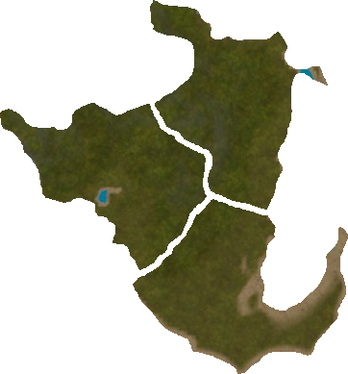
Each player will begin a number of territories (the number being determined by their Path to Glory army size) which will be represented on the battle map. Once a territory has been defined by the original owning player (i.e., Old Keep, Wild Lands etc) then it remains as such even if the territory passes to another player. However, if the territory is captured, any upgrades made to that territory are immediately removed.
One of your starting territories must also be the location of your Stronghold. Each player starts with a standard Stronghold and if they wish to upgrade, they must do so following the path to glory rules.
Standard Path to Glory rules apply throughout this campaign in regards to Glory Points, injuries and casualties etc. Therefore, please follow the aftermath sequence of Path to Glory.

Gaining Territory
After a Path to Glory game, when managing your territories, you can gain any unclaimed territory via exploration rolls as per the path to glory rules and spending the relevant glory points to do so. Please note that all rules in regards to the number of territories a faction can hold applies here.
However, if a player owns a Mighty Stronghold and holds 9 territories that player must build a further standard stronghold on another territory in order to hold any additional territory. Additional strongholds cost 15 glory points to build.
If two players who are neighbours on the battle map fight a battle, then after the game the victorious player may pay 10 glory points to claim a territory that is adjacent to their own from their opponent. If they choose not to, then the battle was considered to be a raid and any upgrades on that territory are lost, however it remains in the original players hands.
Players starting strongholds can never be lost and they retain this territory no matter what, however it can be subject to raids.

Fog of War
Once starting locations have been decided, the Games Master (GM) will send out a map to each player which shows bordering territory which can be claimed. The players must notify the GM of which territories they wish to lay claim to following exploration rolls and what that territory will be defined as (i.e., Old Keep, Wild Lands etc). Players who border another players territory will be notified of who that neighbouring player is and what that territory is (i.e., Old Keep, Wild Lands etc).

Campaign Length
This is our first campaign so I initially see this running until March next year as a test, however if successful we can extend this further into 2022.
When the campaign ends, the location of the powerful Realmgate of Losille will be revealed.

